# **Name: Abdurrahman Qureshi**

# **Roll No: 242466**

Practical No: 12

**Q) To demonstrate following OOP concept in python**

1. **Polymorphism.**
2. **Constructor with Inheritance**
3. **Method overloading**
4. **Method overriding**
5. **Polymorphism**

**Explain the above concepts with example [ Theory ]**

**Explain the code in your own words**

a) Constructor with Inheritance

CODE:

class Character:

    def __init__(self, name, role, weapon):

        self.name = name

        self.role = role

        self.weapon = weapon

    def show_info(self):

        print(f"Name: {self.name}")

        print(f"Role: {self.role}")

        print(f"Weapon: {self.weapon}")

class Human(Character):

    def __init__(self, name, role, weapon, tribe):

        super().__init__(name, role, weapon)

        self.tribe = tribe

    def show_info(self):

        super().show_info()

        print(f"Tribe: {self.tribe}")

class Machine(Character):

    def __init__(self, name, role, weapon, weakness):

        super().__init__(name, role, weapon)

        self.weakness = weakness

    def show_info(self):

        super().show_info()

        print(f"Weakness: {self.weakness}")

class Tribe(Character):

    def __init__(self, name, role, weapon, territory):

        super().__init__(name, role, weapon)

        self.territory = territory

    def show_info(self):

        super().show_info()

        print(f"Territory: {self.territory}")

aloy = Human("Aloy", "Hunter", "Bow", "Nora")

thunderjaw = Machine("Thunderjaw", "Apex Predator", "Disc Launcher", "Tearblast Arrows")

tenakth = Tribe("Tenakth", "Warrior Tribe", "Spear", "The Clan Lands")

print("--- Human ---")

aloy.show_info()

print("\n--- Machine ---")

thunderjaw.show_info()

print("\n--- Tribe ---")

tenakth.show_info()

OUTPUT:

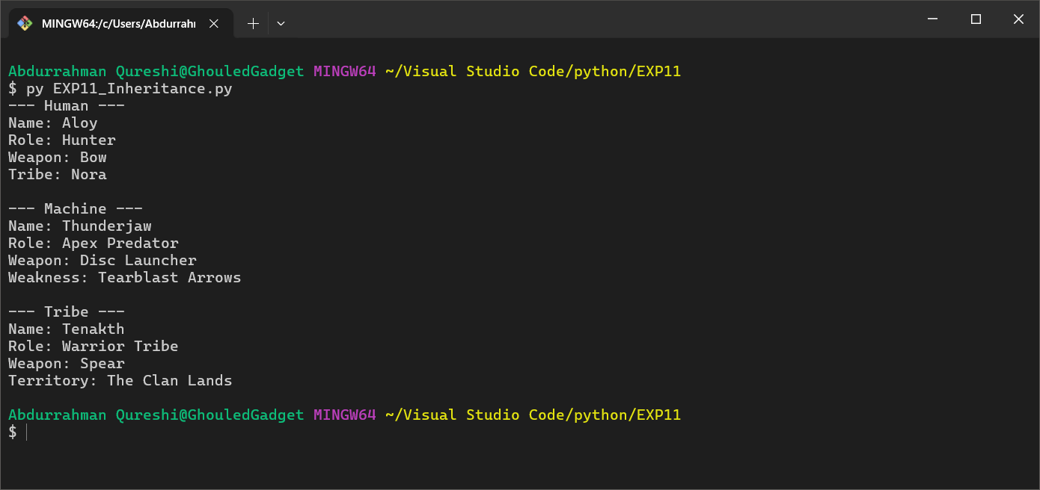

EXPLANATION:

This example demonstrates inheritance with Human, Machine, and Tribe inheriting from Character. Each subclass overrides the show_info method to add specific details like tribe, weakness, or territory, showcasing encapsulation and polymorphism through unique behaviours.

b) Polymorphism – (Method Overloading)

CODE:

class Troop:

    def attack(self, target, weapon=None):

        if weapon:

            print(f"Attacking {target} with {weapon}!")

        else:

            print(f"Attacking {target} with a default weapon!")

class Hero(Troop):

    def attack(self, target, weapon=None, ability=None):

        if ability:

            print(f"Attacking {target} with {weapon} and using {ability}!")

        else:

            super().attack(target, weapon)

archer = Troop()

barbarian_king = Hero()

print("--- Clash of Clans Troops ---")

archer.attack("Enemy Tower")

barbarian_king.attack("Enemy Castle", "Sword", "Iron Fist")

OUTPUT:

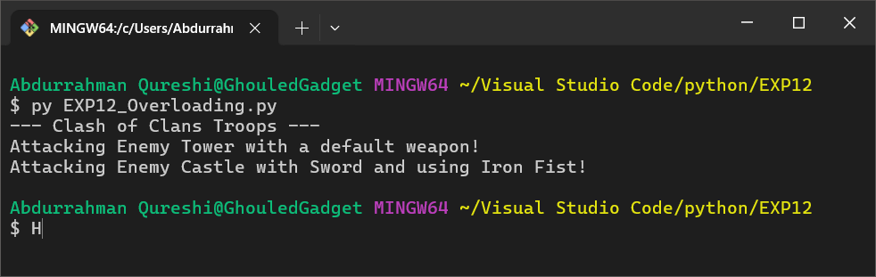

EXPLANATION:

This example shows inheritance with Hero extending Troop. It simulates method overloading in Hero’s attack method using optional parameters (weapon, ability). Polymorphism is demonstrated as attack behaves differently for Troop and Hero objects.

c) Polymorphism - (Method Overriding)

CODE:

class Survivor:

    def __init__(self, name, health):

        self.name = name

        self.health = health

    def use_ability(self):

        print(f"{self.name} uses a generic ability.")

class Coach(Survivor):

    def use_ability(self):

        print(f"{self.name} uses a powerful melee attack to clear zombies!")

class Zoey(Survivor):

    def use_ability(self):

        print(f"{self.name} uses precise shooting to take down the special infected!")

coach = Coach("Coach", 100)

zoey = Zoey("Zoey", 80)

print("--- Left 4 Dead 2 Survivors ---")

coach.use_ability()

zoey.use_ability()

OUTPUT:

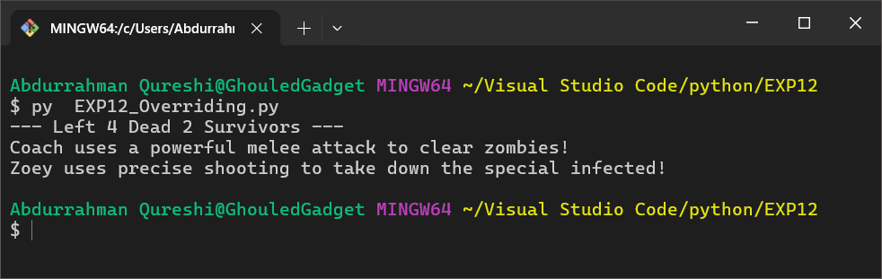

EXPLANATION:

This example highlights inheritance with Coach and Zoey inheriting from Survivor. Both subclasses override the use_ability method to provide unique implementations, demonstrating polymorphism as the method behaves differently based on the object type.

d) Operator Overloading

CODE:

class OnePiece:

    def __init__(self, name, devil_fruit, role, age, gender):

        self.name = name

        self.devil_fruit = devil_fruit

        self.role = role

        self.age = age

        self.gender = gender

    def __ls__(self, next):

        if self.age < next.age:

            return -1

        else:

            return 1

    def __add__(self, next):

        return self.age + next.age

nico_robin = OnePiece("Nico Robin", "Flower Flower Fruit", "Archeologist", 32, "Female")

luffy = OnePiece("Monkey D. Luffy", "Gum Gum Fruit", "Captain", 21, "Male")

print("------------ Nico Robin ------------\n")

print("Name:", nico_robin.name)

print("Gender:", nico_robin.gender)

print("Age:", nico_robin.age)

print("Role:", nico_robin.role)

print("Devil Fruit:", nico_robin.devil_fruit)

print("\n------------ Monkey D. Luffy ------------\n")

print("Name:", luffy.name)

print("Gender:", luffy.gender)

print("Age:", luffy.age)

print("Role:", luffy.role)

print("Devil Fruit:", luffy.devil_fruit)

print("\nCombined Age of both: ", nico_robin + luffy)

if nico_robin.age < luffy.age:

    print("\nNico Robin is younger than Monkey D. Luffy.")

else:

    print("\nMonkey D. Luffy is younger than Nico Robin.")

OUTPUT:

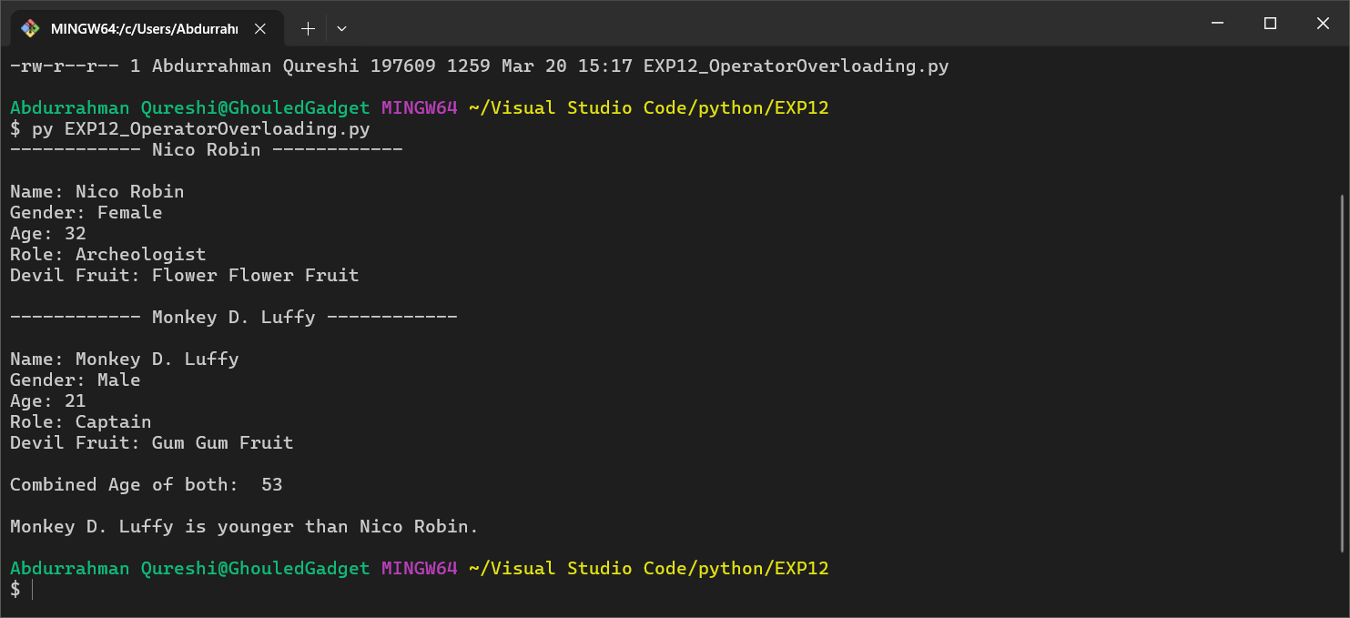

EXPLANATION:

The code defines a OnePiece class with attributes like name, devil_fruit, role, age, and gender. It includes methods __ls__ (unused) and __add__ to compare and sum ages. It creates two characters, displays their details, and compares their ages.

e) Multiple Inheritance

CODE:

class Daddy:

    def __init__(self):

        super().__init__()

    def printDaddy(self):

        print('From Daddy')

class Mommy:

    def __init__(self):

        super().__init__()

    def printMommy(self):

        print('From Mommy')

class Baby(Daddy,Mommy):

    def __init__(self):

        super().__init__()

    def printBaby(self):

        print('I am Baby')

        super().printDaddy()

        super().printMommy()

obj = Baby()

obj.printBaby()

OUTPUT:

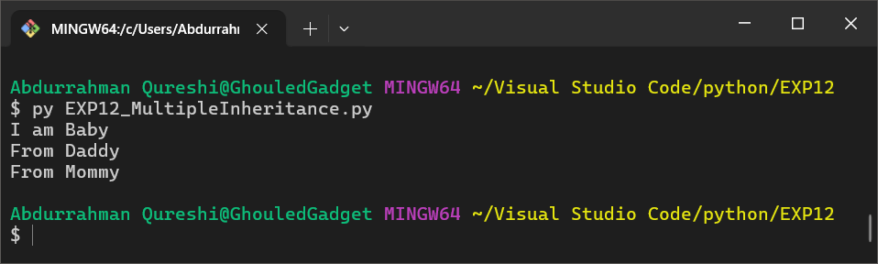

EXPLANATION:

The Baby class inherits from Daddy and Mommy. Its printBaby method prints "I am Baby", then uses super() to call printDaddy ("From Daddy") and printMommy ("From Mommy"). The Method Resolution Order (MRO) ensures proper execution.

f) Method Resolution Order

CODE:

class Daddy:

    def __init__(self):

        self.person='Daddy'

        print(self.person)

        super().__init__()

class Mommy:

    def __init__(self):

        self.person='Mommy'

        print(self.person)

        super().__init__()

class Baby(Daddy,Mommy):

    def __init__(self):

        self.person='Baby'

        print(self.person)

        super().__init__()

obj = Baby ()

OUTPUT:

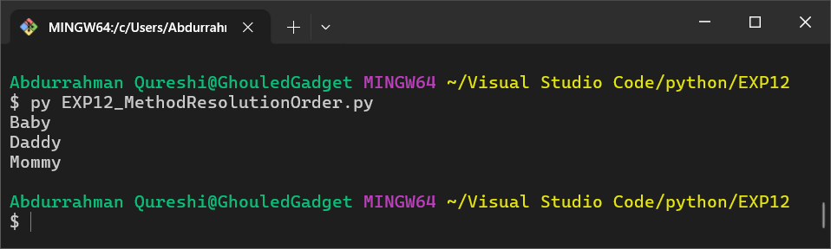

EXPLANATION:

The Baby class inherits from Daddy and Mommy. When obj = Baby() is called, it prints "Baby", then "Daddy", and finally "Mommy" due to the super().__init__() calls and the Method Resolution Order (MRO).